Supplementary Information
Supplementary Figures and Legends
Supplementary Figure. S1

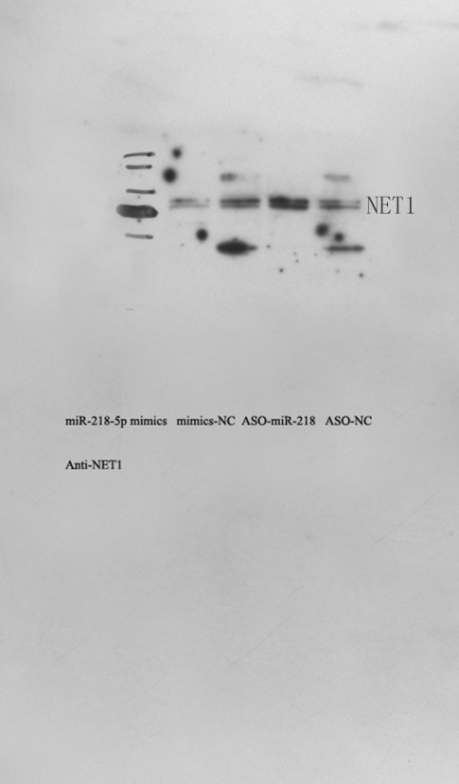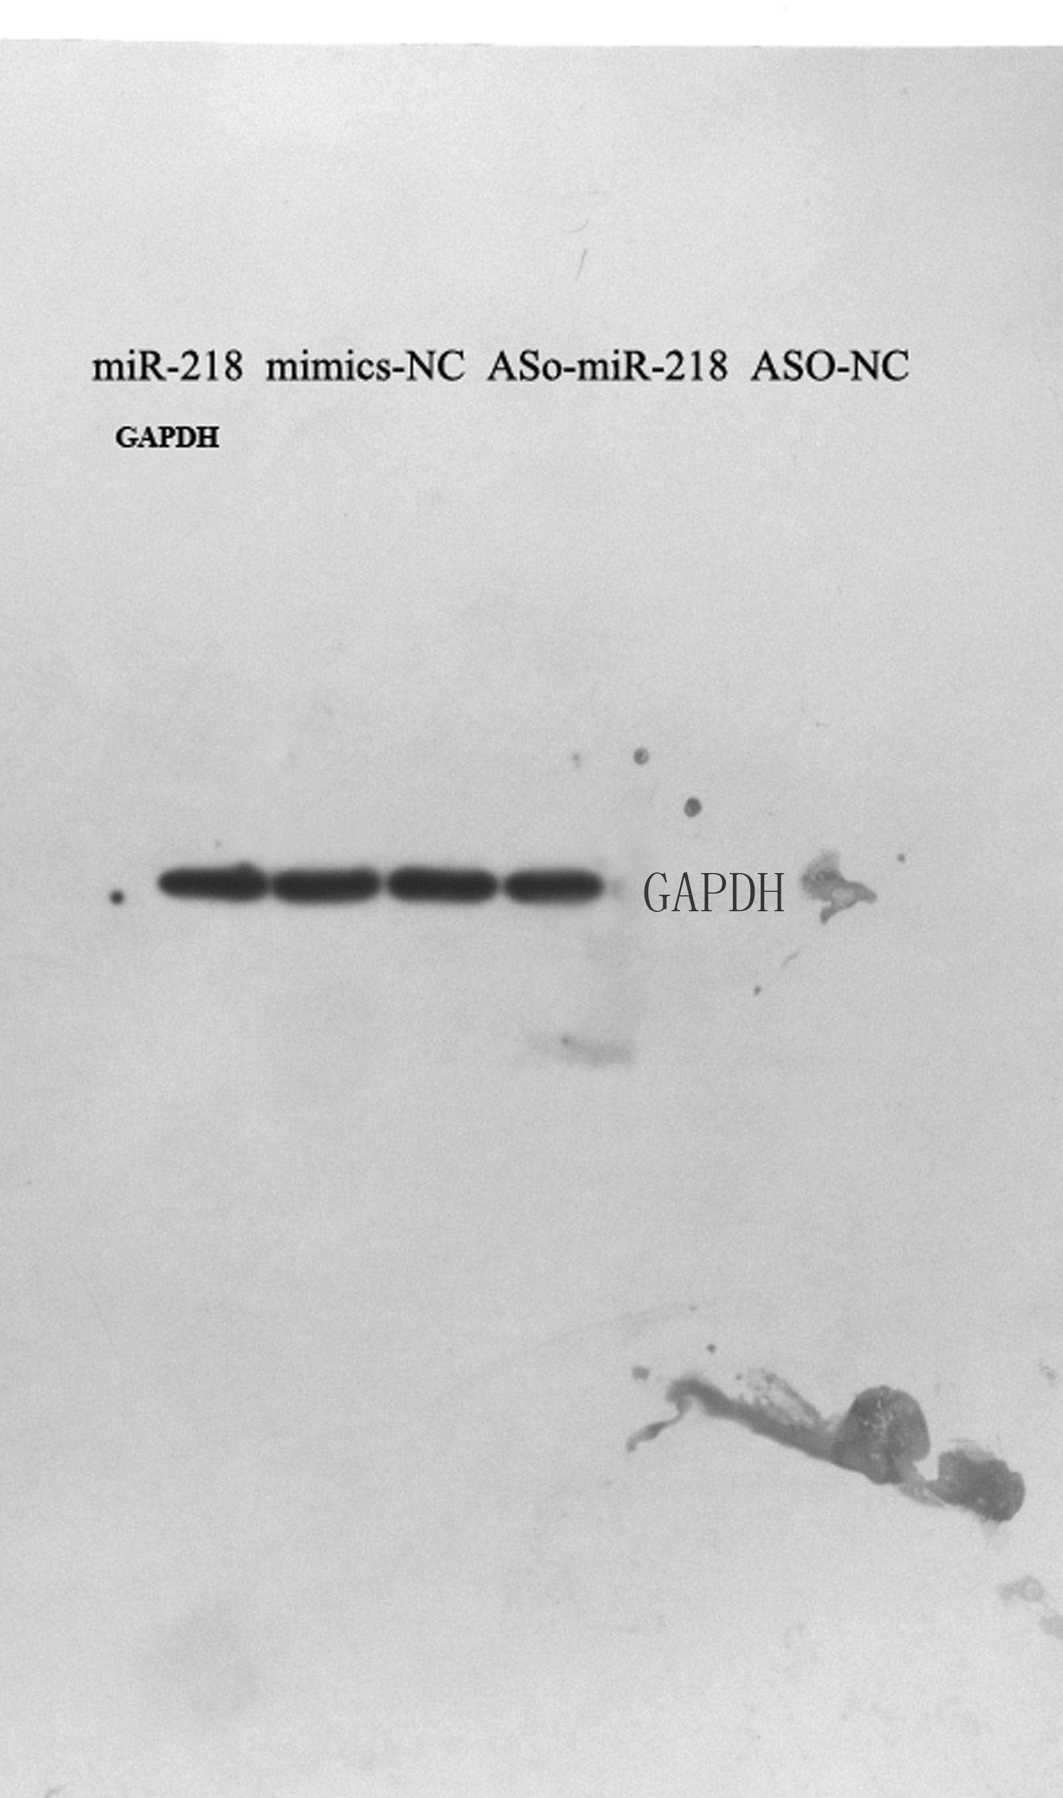
Supplementary Fig. S1. The original images of the blot in figure.3E. The influence of miR-218-5p on endogenous NET1 protein level by western blot. The PhotoShop software was used in cropping of the blot.

Supplementary Figure. S2

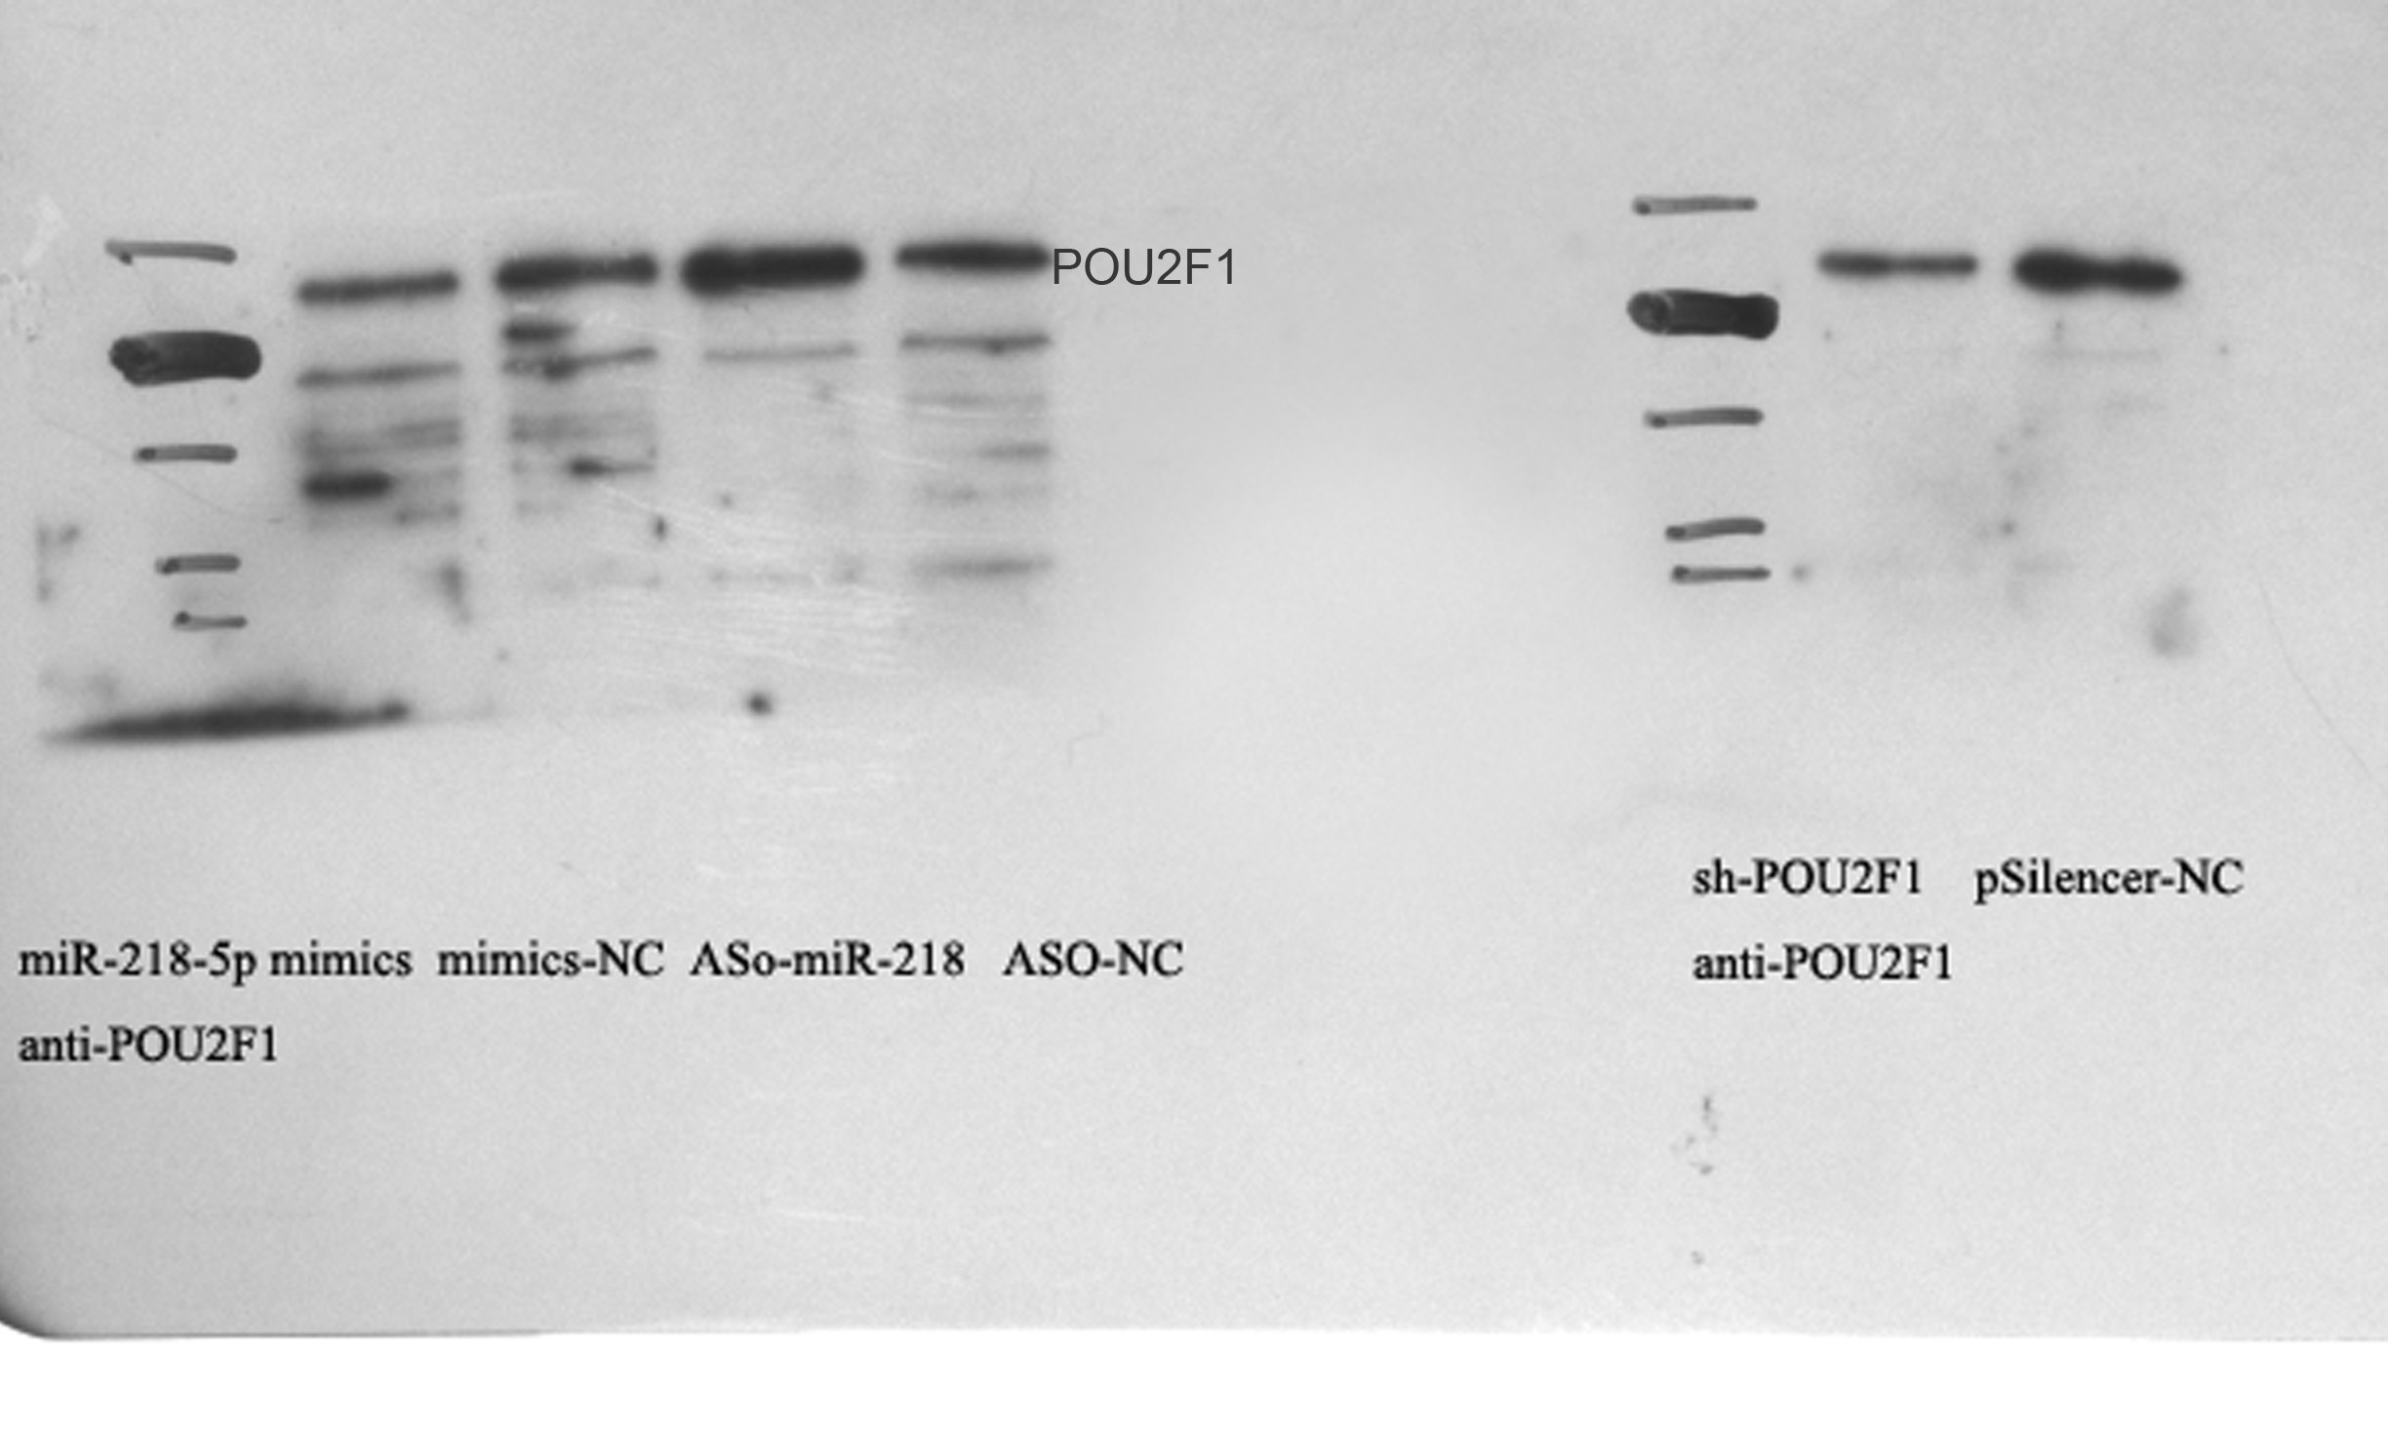
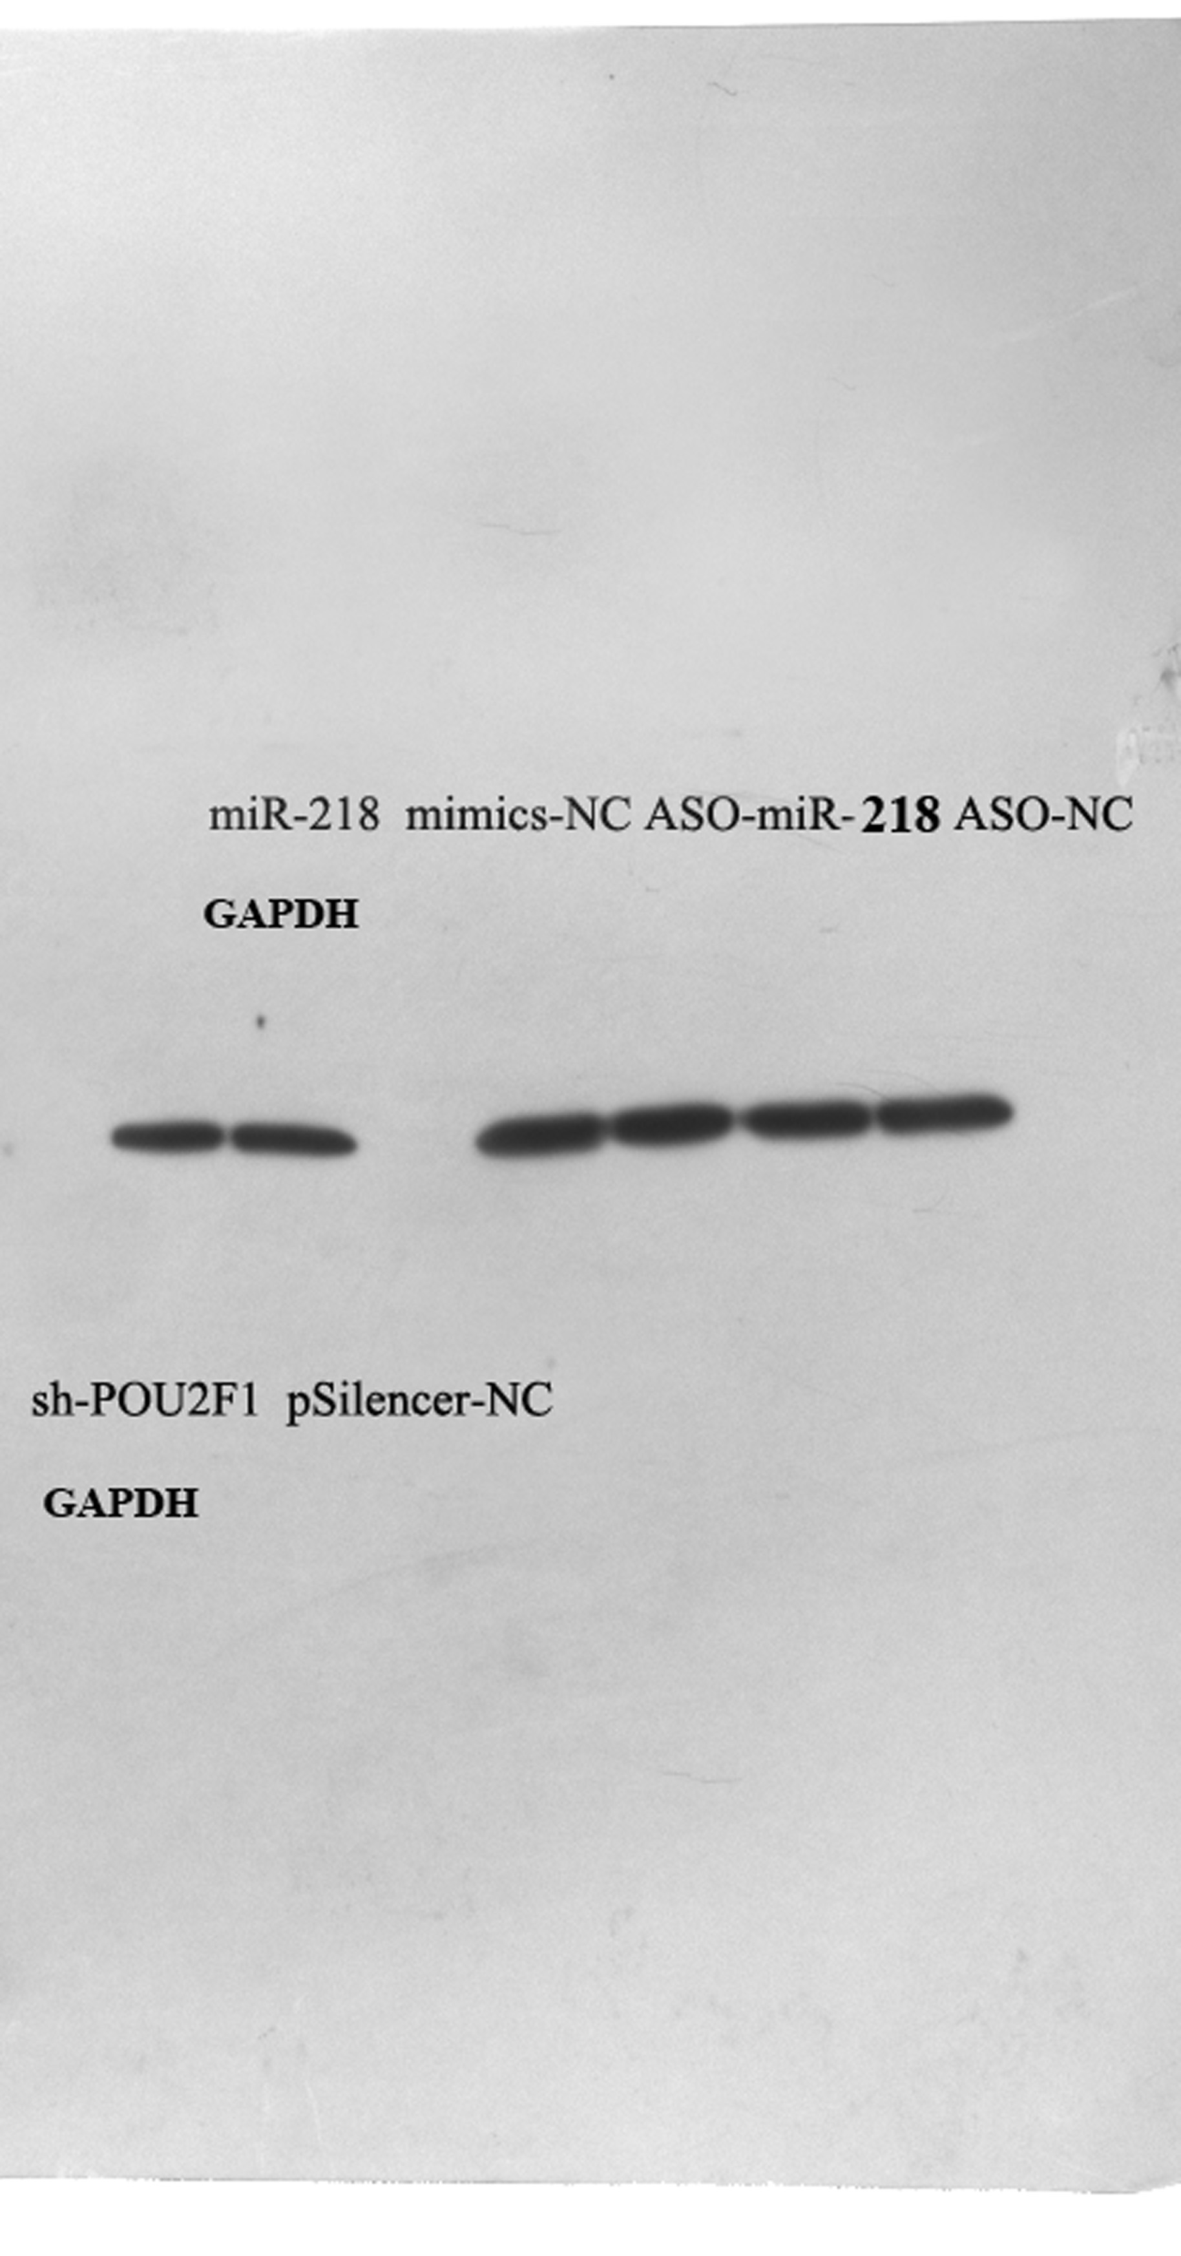
Supplementary Fig. S2. The original images of the blot in figure.3F. The influence of miR-218-5p on endogenous POU2F1 protein level by western blot. The PhotoShop software was used in cropping of the blot.

Supplementary Figure. S3
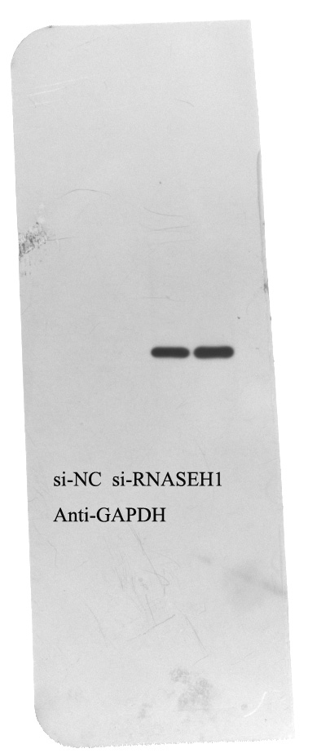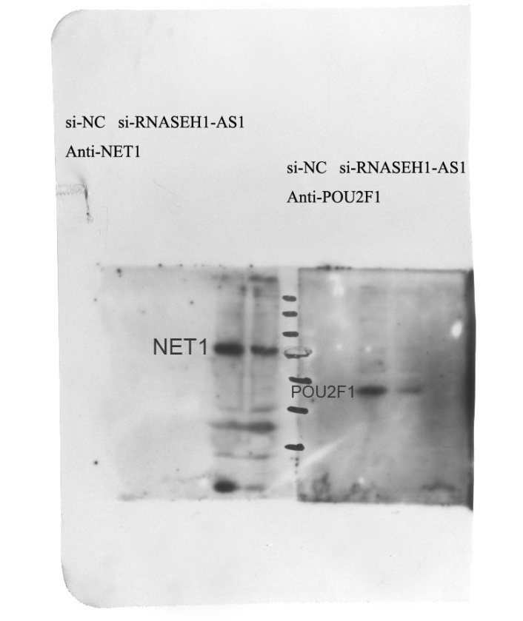
Supplementary Fig. S3. The original images of the blot in figure.4H. The NET1 and POU2F1 protein level in xenograft tumor by western blot after interfering of RNASEH1-AS1. The PhotoShop software was used in cropping of the blot.

Supplementary Figure. S4
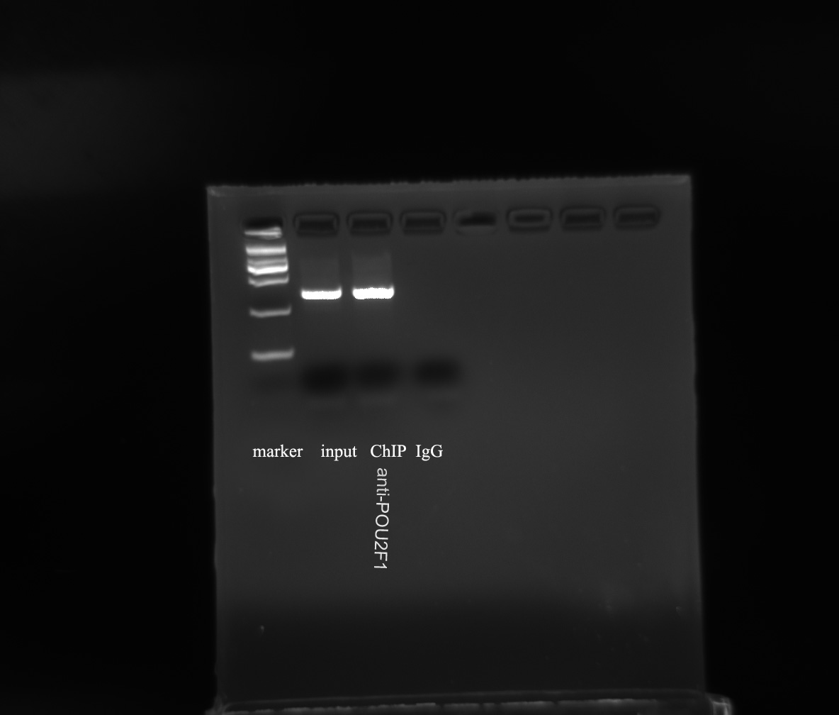
Supplementary Fig. S4. The original images of the blot in figure.5C. The activity of RNASEH1-AS1 promotor by CHIP assay. The PhotoShop software was used in cropping of the blot.

